### Publishable summary

The IDEAS project developed and validated the technologies and business models required for the cost effective and incremental implementation of energy positive neighbourhoods (EPNs). These include:

* A neighbourhood energy management tool to optimise energy production and consumption;
* User interfaces to engage communities and individuals in the operation of energy positive neighbourhoods;
* A decision support urban planning tool to optimise the planning of neighbourhood energy infrastructures;
* Business models to underpin EPNs that engage end users, public authorities and utility companies

The tools and elements of the business modes developed in the project were piloted over 8 months at the Bordeaux University campus in France and the Omenatarha residential neighbourhood in Finland.

At the outset of the project there was no accepted definition of an EPN. Therefore it was necessary to develop such a definition and a set of key performance indicators (KPIs) to measure ‘energy positivity’. These were refined during the lifetime of the project to address the way in which the energy infrastructures of an EPN interact with wider networks. The key elements of the definition are presented below.

***Energy positive neighbourhoods are those in which the annual energy demand is lower than the annual energy supply from local renewable energy sources. Their energy infrastructures are connected to and contribute to the efficient operation and security of the wider energy networks. The aim is to support the integration of distributed renewable energy generation into wider energy networks and provide a functional healthy, user friendly environment with as low energy demand and little environmental impact as possible***

Figure1: The definition of an EPN underpinning the research in the IDEAS project

While the concept underpinning the notion of an EPN in the IDEAS project is that local energy demand is serviced by local renewable energy supply, we are not advocating ‘islanded micro grids’ that operate separately from the national energy networks. It is envisaged that the energy infrastructures of EPNs are not only connected to the wider energy networks but that they contribute to the optimisation and security of those wider energy networks. In this regard the idea that the energy demand of the neighbourhood is predominantly serviced by local renewable energy supply is significant. This is because matching local supply (e.g. solar and wind power) with local demand can mitigate congestion on the electricity distribution network enabling savings on the investments in grid capacity and congestion management required to support distributed renewable energy generation (DREG) in the electricity industry.

The concept of an EPN in IDEAS is underpinned by the notion that the DREG in an EPN will not put extra pressure on congested electricity networks, while electricity can be stored within the EPN and sold outside of the EPN when national energy demand is high. The development of an EPN which operates in this way requires efficient energy markets and service providers that:

* Supply distribute and generate renewable energy within the neighbourhood.
* Optimise the balance between energy production, storage /retrieval and import/export (buying and selling) at the neighbourhood level;
* Engage the relevant communities in Demand Side Management (DSM) and Supply Side Management (SSM);

We have called this new type of service provider an Energy Positive Neighbourhood Service Provider (EPNSP) see figure 2:

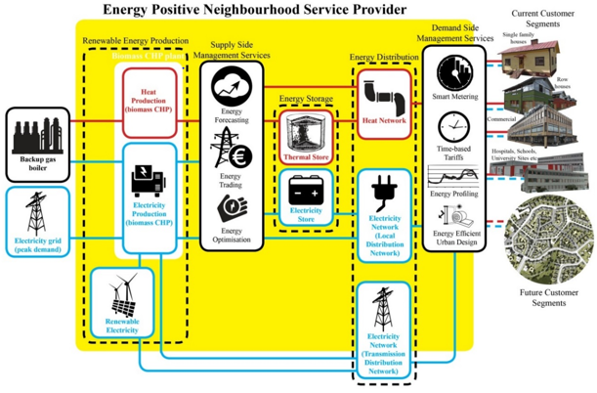.

Figure 2: The concept of an Energy Positive Neighbourhood service provider

The business models developed in the IDEAS project for EPNSPs are integrated business models, in which innovating firms bundle innovation and product together, and assume the responsibility for the entire value chain related to supplying affordable locally produced renewable energy. This will involve the development of partnerships between existing companies involved in the local supply generation and distribution of both heat and electricity. The partnerships required will depend on the current configuration of the companies involved. However the key service providers for an EPN are Distribution network operators (DNOs), Electricity Suppliers, Energy Service Companies (ESCOs) and District Heating Providers (DHP).

The research conducted in the IDEAS project was broken down into three distinct periods: the First Period was 12 months in duration (01/11/12 to 31/10/13), the Second Period was 8 months in duration (01/11/13 to 30/6/14) the Third Period was 16 Months in duration (01/7/14 to 31/10/15)

The initial phase of the research conducted in the First Period of the project developed business models within the context of the demonstration sites. During this phase the specifications for the tools and interfaces required to support an EPN were also developed. The pilot tools were developed during the Second Period. In the third and final phase of the IDEAS project the work done focused on placing the business models developed for the demonstration sites in the wider EU context and piloting of the following tools at two demonstration sites.

* A neighbourhood energy management system (EMS) to optimise storage/retrieval, buying/selling energy and to supply energy demand predictions for energy trading.
* A decision support urban planning tool to estimate the economic and environmental effects (e.g. ROI period and CO2-ekv emissions) on different renewable energy supply options and future building development and redevelopment, which evaluates and gives guidance on the possibilities to meet local energy demand with local renewable supply.
* Two broad types of innovative user interfaces to interact with the occupants of an EPN:
  + Interfaces required for energy consumers and producers to interact with the services required for DSM, SSM and energy trading energy etc. One of the most innovate of these uses real-time augmented reality technology to interact with users and allow them to visualise the real-time energy usage of various household appliances.
  + Community based interfaces and 3D virtual environments that ‘promote’ the concept of an EPN to the occupants of the EPN and the wider public.

In both the pilot demonstrations the focus was on optimising the production and consumption of both heat and electricity. The logic underpinning the demonstrations is presented in the figure 3;

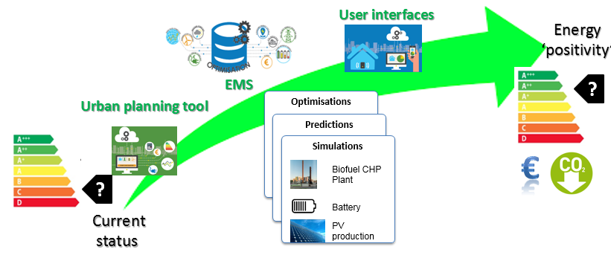

Figure3 Logic of the demonstrations

The scheme illustrated in figure 4 was employed to test the Energy Management System developed in the project. Some of the local energy sources are simulated and several optimisation scenarios were tested to identify the most promising approaches to move the pilot neighbourhoods towards energy positivity.

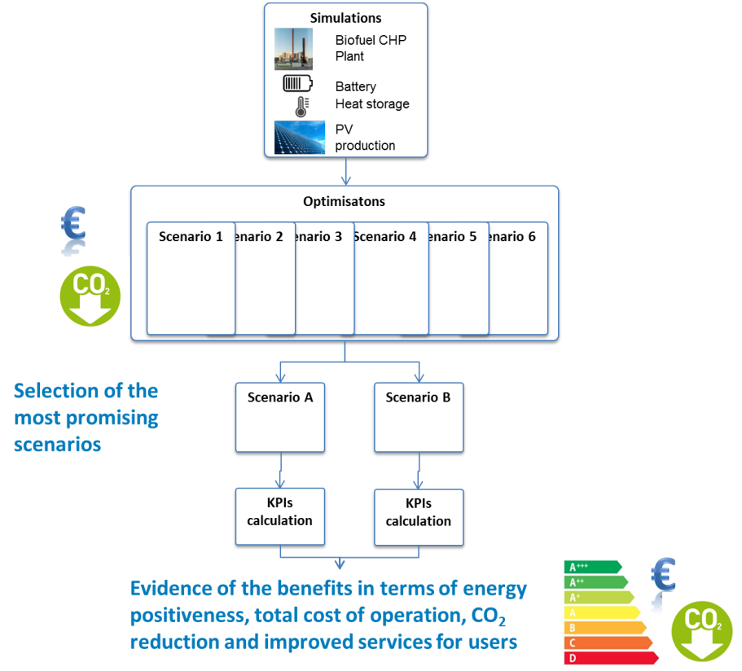

Figure 4: Scheme used to test the Energy Management System

The pilot demonstrations provided evidence of the benefits in terms of total cost of neighbourhood operation, CO2 reduction and improved services for users. They also examined the potential for scaling up the pilot cases and tested various aspects of the business models. Key findings related to the implementation of the tools are presented in figure 5.

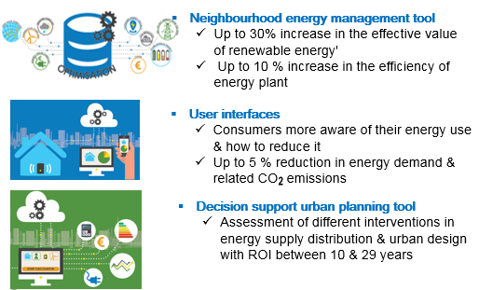

Figure 5: Impact of the tools demonstrated at the pilot sites

The idea that ‘community energy project’ financing offers a route to community engagement in the development of EPNSPs is supported research undertaken in the pilot studies. A survey of Finnish people living in and around the Omenatarha residential neighbourhood in Finland found that 75 percent of people felt they were more likely to invest in co-operative community renewable energy projects than they were to invest in renewable technologies in their houses such as PV panels on their homes. The possibilities of community energy project financing for funding EPNSPs also seems to be supported by the growth of community energy projects across the EU.

Looking at the wider context the IDEAS project contributed to:

* The opening of a market for ICT-based district/community energy management systems.
  + The IDEAS Total Solution for an EPN can reduce energy costs by up to 58%.
  + IDEAS Energy Management System enables up to a 30% increase in the revenue generation from distributed renewable electricity and heat production and a 10 % increase in the efficiency of distributed renewable plant.
* Establishment of a collaboration framework between the ICT sector, the buildings and construction sector and the energy sector.
  + The results of the IDEAS project were presented at 31 conferences and 7 dissemination workshops with related RTD projects with a total audience of over 8565 people. In addition the IDEAS consortium published 10 peer reviewed conference papers & 5 professional journal articles.
  + Since October 2013 over 8000 users accessed the IDEAS website and there have been some 4728 views of the webinar that presented the findings of the project in less than a month.
  + As a result of the wide dissemination of the projects outcomes the operational concept of an EPN (the EPN definition, KPIs and energy positivity label) is informing discussions in other European projects involving stakeholders from the ICT, energy, buildings and construction sectors. (e.g. Design4Energy, CityKeys and DRBOB).
* Quantifiable and significant reduction of energy consumption and CO2 emissions achieved through ICT.
  + The IDEAS Total Solution for an EPN is able to reduce CO2 emissions by up to 58%.

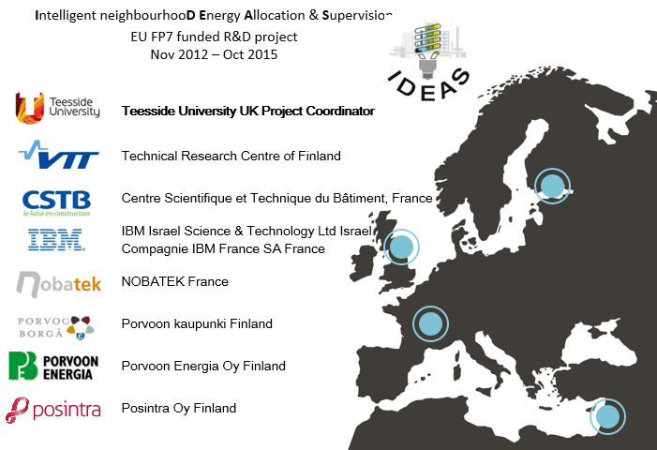

**For further details see:** [**http://www.ideasproject.eu**](http://www.ideasproject.eu)